# Brainstorm

**TIP**

You can select a sticky note and hit the pencil [switch to sketch] icon to start drawing!

## Before you collaborate

### A little bit of preparation goes a long way with this session. Here’s what you need to do to get going.

#### 10 minutes

**1**

## Define your problem statement

### What problem are you trying to solve? Frame your problem as a How Might We statement. This will be the focus of your brainstorm.

#### 5 minutes

**2**

## Brainstorm

### Write down any ideas that come to mind that address your problem statement.

#### 10 minutes

**3**

## Group ideas

### Take turns sharing your ideas while clustering similar or related notes as you go. Once all sticky notes have been grouped, give each cluster a sentence-like label. If a cluster is bigger than six sticky notes, try and see if you and break it up into smaller sub-groups.

#### 20 minutes

**4**

## Prioritize

### Your team should all be on the same page about what's important moving forward. Place your ideas on this grid to determine which ideas are important and which are feasible.

#### 20 minutes

**After you collaborate**

You can export the mural as an image or pdf to share with members of your company who might find it helpful.

**Quick add-ons**

**& idea prioritization**

**TIP**

Add customizable tags to sticky notes to make it easier to find, browse, organize, and categorize important ideas as themes within your mural.

if the car has met with an accident before

collaborate with car companies

manufacturing year and model

**PROBLEM**

This project focuses on building a system that can accurately predict resale value of the car based on minimal features like km driven, year of purchase, fuel type, etc.

##### A Team gathering

Define who should participate in the session and send an

**JAYARAAJ C N**

predict the

##### JACK NICHOLAS A

user should

value is calculated without human intrusion except feeding car details

##### VIGNESH B

application if the car has

##### MANIKANDAN S

also provide

##### Share the mural

Use this template in your own brainstorming sessions so your team can unleash their imagination and start shaping concepts even if you're not sitting in the same room.

predict the rate according to current trends

invite. Share relevant information or pre-work ahead.

1. **Set the goal**

Think about the problem you'll be focusing on solving in the brainstorming session.

1. **Learn how to use the facilitation tools**

Use the Facilitation Superpowers to run a happy and productive session.

rate according to current trends

number of historical owners should be considered

if the car has met with an accident before

user should enter the details of the car then value is calculated automatically

if the car has history of crimal records

easy to use interface

number of historical owners should be considered

###### easy to use interface

revenue by providing ad spaces to car manufacturers in application

enter the details of the car then value is calculated automatically

###### include more input data se

Analyze History of Vehicle

predict the efciency of the model based on existing data

can include sensors to detect the value easily

provide information about the nearest service stations for the model

history of crimal records

accurate prediction of rate of the vehicle is important

Insurance details of the car

###### user friendly application

collaborate with car companies

can provide space for advertisements

provide ways to input image of the vehicle into the application

manufacturing year and model

also provide Insurance details of the car

Analyze History of Vehicle

accurate prediction of rate of the vehicle is important

revenue by providing ad spaces to car manufacturers in application

provide information about the nearest service stations for the model

number of historical owners should be considered

can provide space for advertisements

can provide space for advertisements

predict the efciency of the model based on existing data

also provide Insurance details of the c

**Share a view link** to the mural with stakeholders to keep them in the loop about the outcomes of the session.

**B Export the mural**

Export a copy of the mural as a PNG or PDF to attach to emails, include in slides, or save in your drive.

**10 minutes** to prepare

**1 hour** to collaborate

**2-8 people** recommended

[**Open article**](https://support.mural.co/en/articles/2113740-facilitation-superpowers)

predict the rate according to current trends

accurate prediction of rate of the vehicle is important

easy to use interface

user friendly application

application can include sensors to detect the value easily

**Key rules of brainstorming**

To run an smooth and productive session

**Keep moving forward**

**Strategy blueprint**

Define the components of a new idea or strategy.

[**Open the template**](https://app.mural.co/template/e95f612a-f72a-4772-bc48-545aaa04e0c9/984865a6-0a96-4472-a48d-47639307b3ca)

**Customer experience journey map**

Stay in topic. Defer judgment.

provide ways to input image of the vehicle into the application

include more input data set

value is calculated without human intrusion except feeding car details

Encourage wild ideas. Listen to others.

**Importance**

If each of these

Understand customer needs, motivations, and obstacles for an experience.

[**Open the template**](https://app.mural.co/template/b7114010-3a67-4d63-a51d-6f2cedc9633f/c1b465ab-57af-4624-8faf-ebb312edc0eb)

provide information about the nearest service stations for the model

include more input data set

Go for volume. If possible, be visual.

tasks could get

done without any difficulty or cost, which would have the most positive impact?

**Strengths, weaknesses, opportunities & threats**

Identify strengths, weaknesses, opportunities, and threats (SWOT) to develop a plan.

provide ways to input image of the vehicle into the application

[**Open the template**](https://app.mural.co/template/6a062671-89ee-4b76-9409-2603d8b098be/ca270343-1d54-4952-9d8c-fbc303ffd0f2)

**TIP**

Participants can use their cursors to point at where sticky notes should go on the grid. The facilitator can confirm the spot by using the laser pointer holding the **H key** on the keyboard.

[**Share template feedback**](https://muralco.typeform.com/to/CiqaHVat?typeform-source=app.mural.co)

[**Share template feedback**](https://muralco.typeform.com/to/CiqaHVat?typeform-source=app.mural.co)

**Feasibility**

Regardless of their importance, which tasks are more feasible than others? (Cost, time, effort, complexity, etc.)

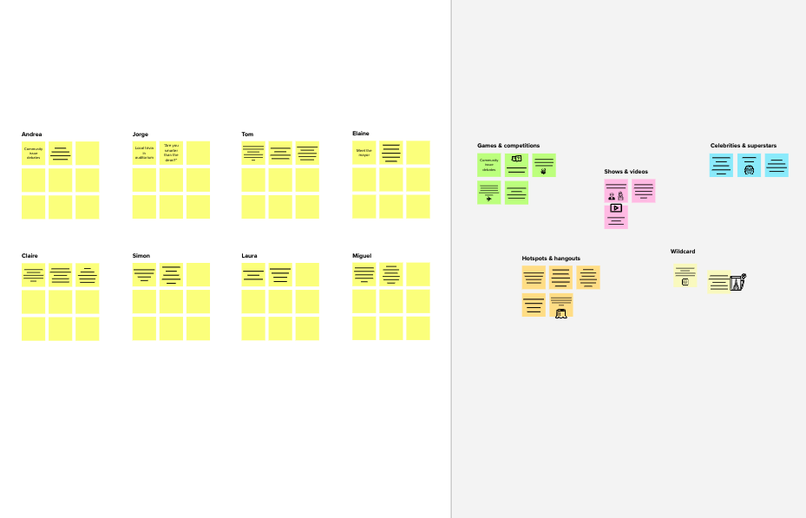

**Template**

**Need some inspiration?**

See a finished version of this template to kickstart your work.

[**Open example**](https://app.mural.co/template/e5a93b7b-49f2-48c9-afd7-a635d860eba6/93f1b98d-b2d2-4695-8e85-7e9c0d2fd9b9)